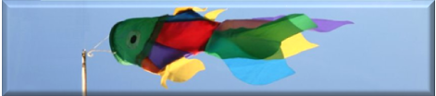
Weather for Schools
________________________________________________________________
Taking Air Pressure Readings Video
Let’s take the air pressure reading from this barometer.
Move the pointer to record the previous air pressure.
[The pointer is moved.]
Tap the glass to see the current air pressure.
[The glass is tapped, and the pointer moves.]
Look to see if the air pressure has risen, fallen or stayed the same.

